Booking Timings Windows: 10 AM to 4:30 PM

Customer Id Login:
- Use Customer Id in CMS-P (https://p.comtrack.in). If you don’t have customer id yet, kindly refer to our document “Customer ID for multiple CMSP accounts” under label “Latest Updates” on Comtrack Home Page i.e. https://comtrack.in.
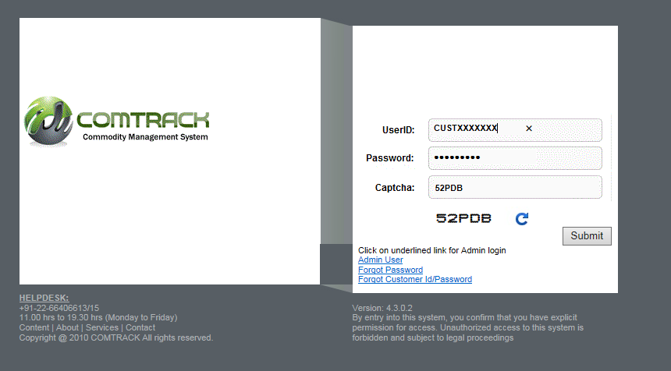

- Go to Menu > Warehouse Reservation > Warehouse Reservation

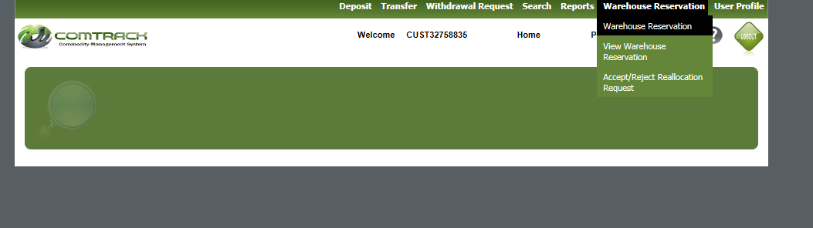

- Fill details on the warehouse reservation page :
  - Values with * are mandatory.
  - Values in white background are editable fields
  - Values in cream background are auto populated as the transaction goes ahead.
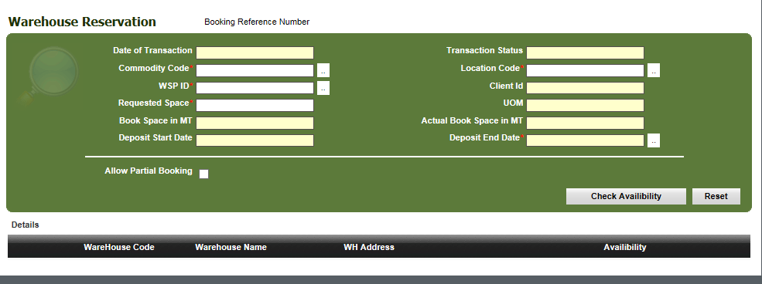

- Choose
  - the commodity for which booking needs to be done at your location
  - Select the desire WSP and enter quantity for which space is required to be booked.
  - Click on check availability.
  - List of Warehouses for the given criteria shall appear with the warehouse details and available bookable capacity of the warehouse.
Note: The available warehouse capacity is calculated on the basis of approved warehouse space and existing stock present in the warehouse as available in CMSP system as of Previous day and is confirmed by WSP. With every booking request, available bookable space reduces.

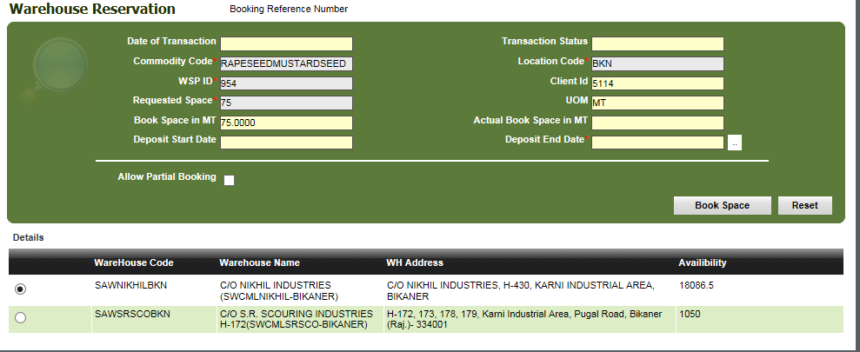

- Choose Deposit End date Click on Book Space to place your booking request.

  - Deposit Start Date would be the next working day of the selected warehouse based on the holiday calendar defined by WSP for their respective warehouse.
  - Select Deposit End Date as the date by which you would finish deposit process for the booked quantity.
Note: Deposit End Date is of significance for WSP to see that depositor completes deposit process on or before the requested date. In view of client not completing the deposit process up to deposit end date, WSP may mark the booking request as NO SHOW for the remaining booked quantity.

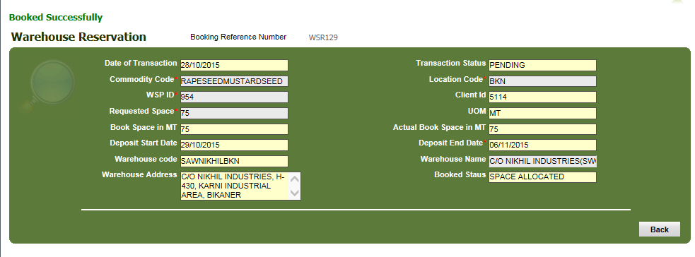

- On Clicking Book Space: Depending on the available capacity, warehouse space reservation request will be sent approval. Unique WSR*** number will be generated for each booking request. This Unique WSR*** unique number may be used by you to trace the reservation status.

- You shall also receive confirmation emails about booking requests on your registered email id.

- Client to make payment of advance pre-electronic credit warehouse charges in COMTRACK and communicate the payment details along with the Booking request ID to the respective WSP on the Booking day.

- WSP shall approve or reject the Booking request based on the payment made by the client, within the given timeframe provide by NERL. On approval/Rejection by WSP, you shall receive emails and SMS about booking requests on your registered email id and mobile numbers.

- On Approval, you are requested to start process of deposit from the Deposit start Date and Finish deposit process on or before Deposit End Date.

- You may trace your booking requests online as given below :
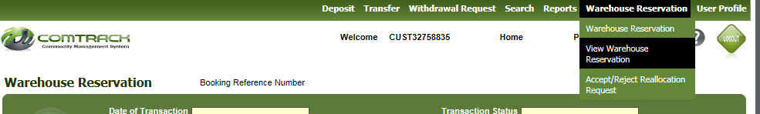

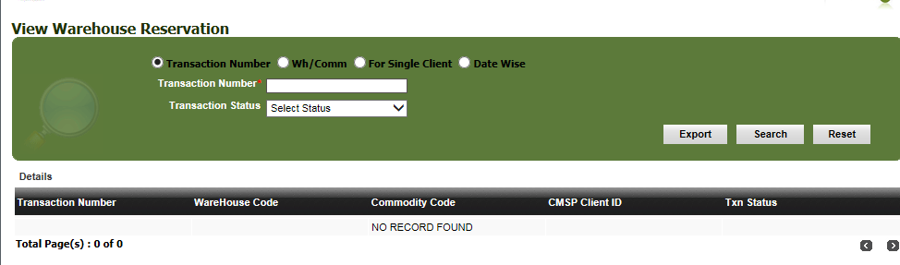

- Use given filters to search your booking request, choose the transaction number and click to view the details
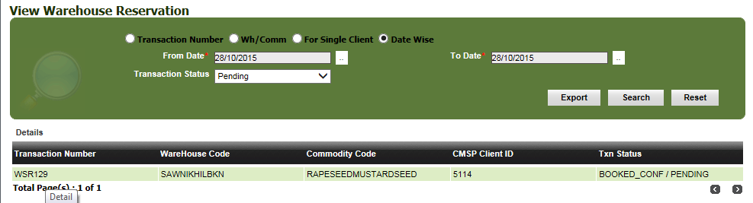

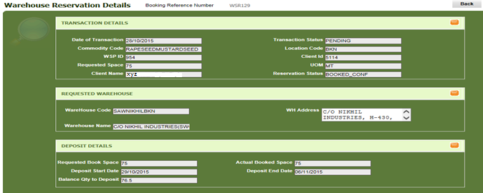

Allow Partial Booking
While booking request with option “Allow Partial Booking” will allow the depositor to book space for the available capacity even if the requested space in more than the available space i.e. if a depositor wants to book space for 1000MT and available space is 800MT, by selecting partial booking client can request for the available same else the entire requested quantity will be forwarded to Waitlist request.

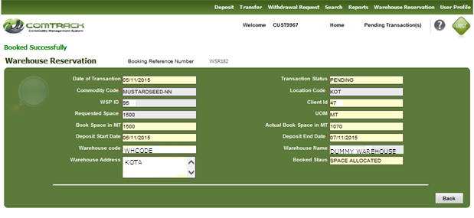

Window

Activities related to warehouse space booking through WSR system is indicated below:
Windows | Start time | End time
Booking Window | 10:00am | 04:30pm
WSP approval window | 04:35pm | 06:00pm
Space Inject window | 06:05pm | 06:30pm
Wait-list approval window | 06:35pm | 07:00pm

